The initial plan, also called « Project organization manual » or POM, aims to inform stakeholders about the principal elements of the project: planning, management, organization, and control.
The manual provides information on how the project starts, on its realisation, and how it is finalized. It allows a uniform and efficient management of the activities to be performed and of the deliverables to be produced. In addition, it enables stakeholders to rapidly overview the standards and tools used in the project. Finally, the manual facilitates the coordination of activities.

Philip Morris: Data analysis improvement of ciliary beating of 3D epithelial tissue

Initial plan

Team and contact information:
Simon Jenni – simujenni@students.unibe.ch
Laurent Hayez – laurent.hayez@unine.ch

[Date]

Version [no]

Table of contents
1. Project description 4
1.1. Project context 4
1.2. Goals and objectives of the project 4
2. Project organization 5
2.1. Responsibility distribution 5
2.2. Interactions with the client 5
3. Methodology 6
3.1. State of the art 6
4. Constraints and elements of risk 7
5. Deliverable goods 8
6. Efforts and schedule 9

Version monitoring
Monitoring of the version in this project organization document enables following modification activities progress within the project. The version is changed only if a major change takes place. Otherwise, only a decimal is changed (1.0 to 1.1)
Version | Update date | Page modified
1.0

Project description
This part is useful for having an executive view over the project.

Project context
Present the client and describe what motivates the project.
Philip Morris International (PMI) is a global cigarette and tobacco company with headquarters in Lausanne. The research and development program of PMI focuses on the development of products with the potential to reduce the risk of tobacco related diseases. To this end, new products are tested against ordinary cigarettes by exposing human tissue cultures to smoke or aerosol of both products. The effect of the exposure is then analysed by observing different features of the tissue, one of which is the ciliary beating.

Goals and objectives of the project
Give a clear and precise description of projects goals and objectives. Be concise and precise.
- A goal is a general statement of intent.
- An objective has to be quantifiable or has to have more precise intentions than the goal.
The goal of this project is to implement a tool for the automatic analysis of ciliary beating in tissue movies. Concretely the objectives are the following:
- Allowing batch processing of video-data contained in a folder (including subfolders).
- Pre-processing of the video data in order to remove noise.
- Scoring the tissue surface activity and storing the results in a colour-map.
- Determine the frequency distribution given per region of interest (ROI) and extract the dominant frequency.
- Processing should be possible on multiple scales, i.e. ROI of variable size.
- Illustrate the phase of the beating frequency in regions of similar beating frequency.

Project organization

Responsibility distribution
The structure of the project involves sharing of responsibility. Here we find key players, their contact information as well as their roles and responsibilities.

Interactions with the client
How will the team members interact with each other and with the client?

Methodology
The methodology should describe the approaches, methods and tools that the team will use to achieve its objectives. You have to describe what you will need for the realization of the project. Information about licensing should be included here. Git will be used as version control tool.

The implementation of the tool will be carried out in Matlab. The decision to use Matlab has been taken in agreement with the client and is based on the ease of handling image and video processing and the relatively fast development time that Matlab provides.

Development will be done in an incremental and iterative fashion roughly following the SCRUM framework. The objectives will be distributed across sprints of two weeks each. Sprint planning of the first sprint has already been done and has the goal of providing an implementation of the minimal requirements. To keep track of the progress and help manage the project we will make use of Taiga, an open source project management platform similar to JIRA. Both the client and project stakeholders will have access to Taiga and will be able to follow the progress if they wish to do so.

To ensure correctness of the implementation, testing using synthetic test-data will be an essential part or the development process. In order to further improve code-quality, code reviews by the other developer will be performed for every task.

State of the art

Constraints and elements of risk
Describe the major hypotheses, constraints and potential risks related to the project (missing components, gaps in knowledge, tasks more difficult than expected, problems with legacy code,…). Explain how they can be lived with or resolved.

Deliverable goods
This section describes the deliverables that need to be produced.

Efforts and schedule
This section includes the project efforts and schedule. The deliverables, the management and the realisation should be included in a time grid like a Gantt chart. It is essential to the success of the project that this schedule is adapted and revised regularly in order to anticipate delays in delivery, management or realisation.
As discussed in section 3, we apply a scrum-based approach and distribute the tasks across six sprints in total. The idea is to have a deliverable product at the end of each sprint, adding new features every next sprint.
Sprint planning will be done at the end of the current sprint, adjusting the plan if necessary due to issues that occurred during the sprint. The following stories are planned for sprint 1:
- Loading and extraction of video data
- Synthetic test data generation
- Frequency analysis per ROI using FFT
- Scoring tissue surface activity
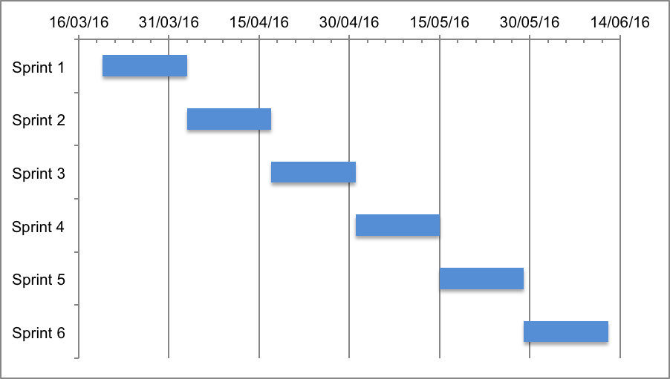
Figure 1: Rundown chart of the sprints

